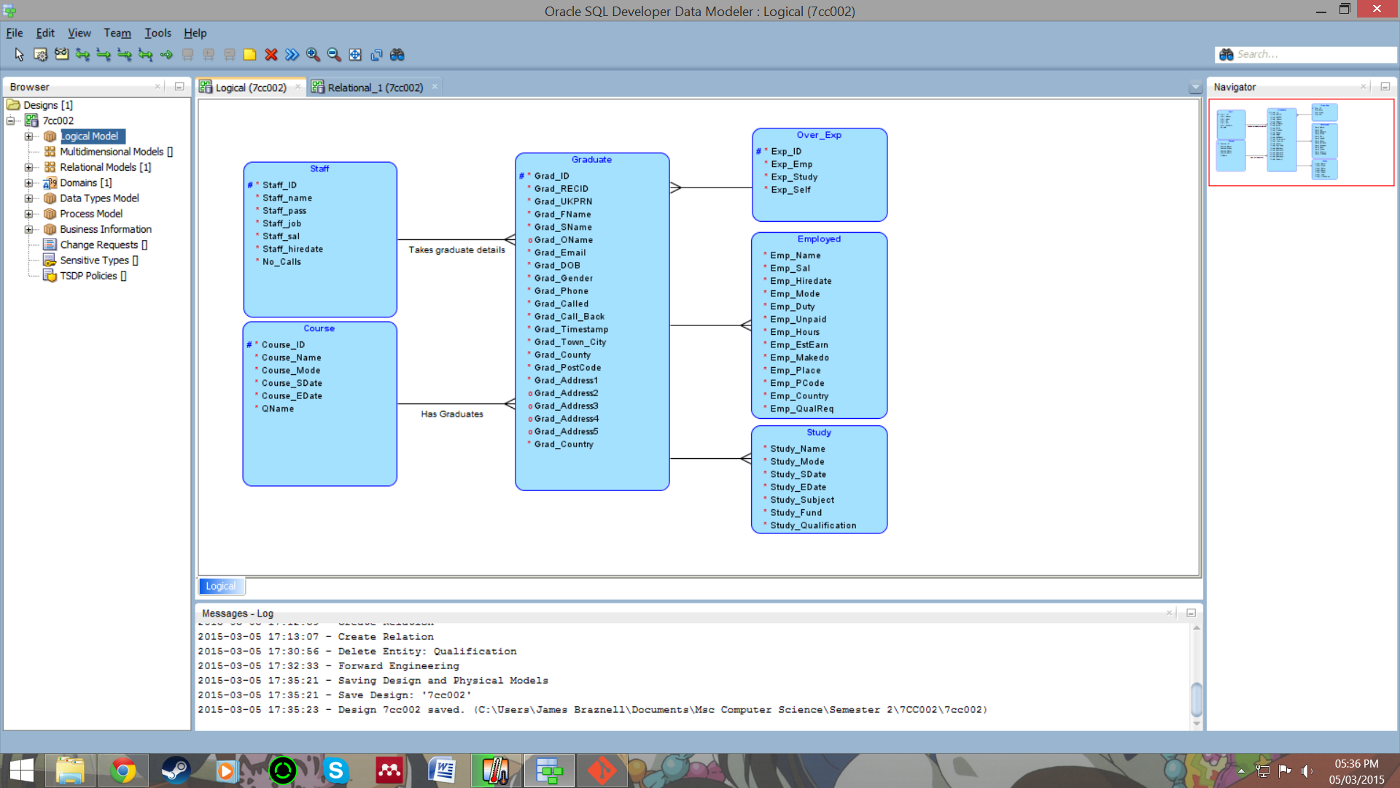**Logical model:**

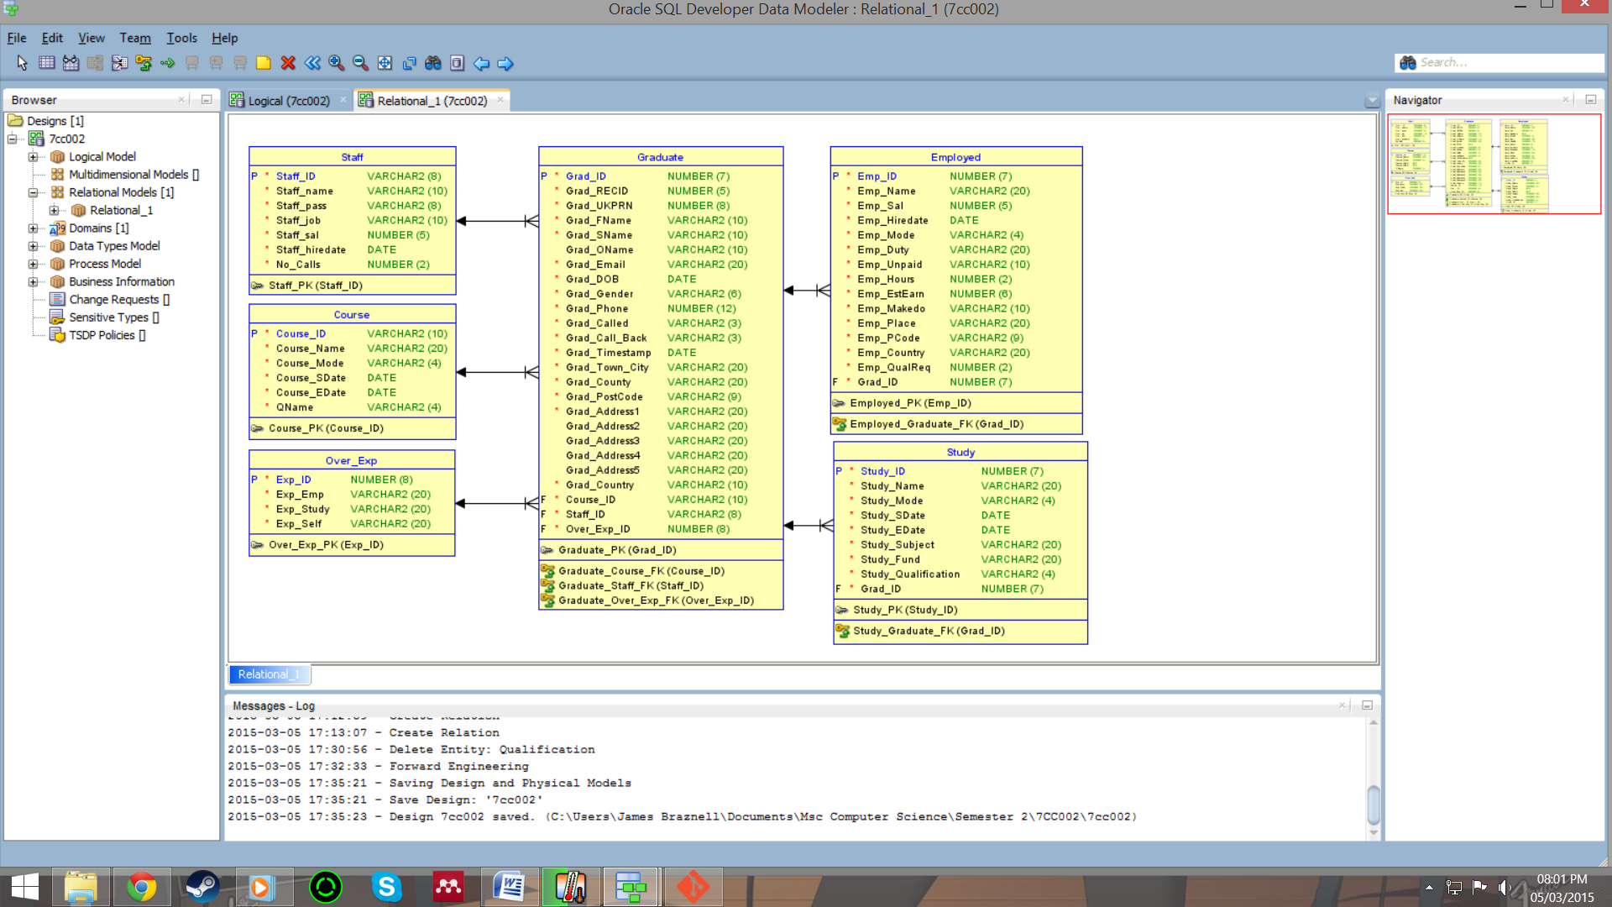**Relational Model:**

**Course -**

* Course_ID - Varchar2 with a maximum length of ten
* Course_Name - Varchar2 with a maximum length of twenty
* Course_Mode - Varchar2 with a maximum length of four
* Course_SDate - Date type
* Course_EDate - Date type
* QName - Varchar2 with a maximum length of four

**Graduate -**

* Grad_ID - Number with a maximum length of seven
* Grad_RECID - Number with a maximum length of five
* Grad_UKPRN - Number with a maximum length of eight
* Grad_FName - Varchar2 with a maximum length of ten
* Grad_SName - Varchar2 with a maximum length of ten
* Grad_OName - Varchar2 with a maximum length of ten
* Grad_Email - Varchar2 with a maximum length of twenty
* Grad_DOB - Date type
* Grad_Gender - Varchar2 with a maximum length of six
* Grad_Phone - Number with a maximum length of twelve
* Grad_Called - Varchar2 with a maximum length of three
* Grad_Call_Back - Varchar2 with a maximum length of three
* Grad_Timestamp - Date type
* Grad_Town_City - Varchar2 with a maximum length of twenty
* Grad_County - Varchar2 with a maximum length of twenty
* Grad_PostCode - Varchar2 with a maximum length of nine
* Grad_Address1 - Varchar2 with a maximum length of twenty
* Grad_Address2 - Varchar2 with a maximum length of twenty
* Grad_Address3 - Varchar2 with a maximum length of twenty
* Grad_Address4 - Varchar2 with a maximum length of twenty
* Grad_Address5 - Varchar2 with a maximum length of twenty
* Grad_Country - Varchar2 with a maximum length of ten
* Course_ID - Foreign key linking to course table as Varchar2 with maximum length of ten
* Staff_ID - Foreign key linking to staff table as Varchar2 with maximum length of eight
* Over_Exp_ID - Foreign key linking to Over_Exp table as number with a maximum length of eight

**Employed -**

* Occupation_ID - Number with a maximum length of eight
* Emp_Name - Varchar2 with a maximum length of twenty
* Emp _Sal - Number with a maximum length of five
* Emp _Hiredate - Date type
* Emp_Mode - Varchar2 with a maximum length of four
* Emp_Duty - Varchar2 with a maximum length of twenty
* Emp_Unpaid - Varchar2 with a maximum length of ten
* Emp_Hours - Number with a maximum length of two
* Emp_EstEarn - Number with a maximum length of six
* Emp_MakeDo - Varchar2 with a maximum length of ten
* Emp_Place - Varchar2 with a maximum length of twenty
* Emp_PCode - Varchar2 with a maximum length of nine
* Emp_Country - Varchar2 with a maximum length of twenty
* Emp_QualReq - Number with a maximum length of two
* Grad_ID - Foreign key linking to graduate table as Number with a maximum length of seven

**Study -**

* Occupation_ID - Number with a maximum length of eight
* Study_Name - Varchar2 with a maximum length of twenty
* Study_Mode - Varchar2 with a maximum length of four
* Study_SDate - Date type
* Study_EDate - Date type
* Study_Subject - Varchar2 with a maximum length of twenty
* Study_Fund - Varchar2 with a maximum length of twenty
* Study_Qualification - Varchar2 with a maximum length of four
* Grad_ID - Foreign key linking to graduate table as Number with a maximum length of seven

**Staff** **-**

* Staff_ID - Varchar2 with a maximum length of eight
* Staff_name - Varchar2 with a maximum length of ten
* Staff_pass - Varchar2 with a maximum length of eight
* Staff_job - Varchar2 with a maximum length of ten
* Staff_sal - Number with a maximum length of five
* Staff_hiredate - Date type
* No_Calls - Number with a maximum length of two

**Over_Exp -**

* Exp_ID - Number with a maximum length of eight
* Exp_Emp - Varchar2 with a maximum length of twenty
* Exp_Study - Varchar2 with a maximum length of twenty
* Exp_Self - Varchar2 with a maximum length of twenty